FOR IMMEDIATE RELEASE
New resources open Somerset’s stunning coastline to more visitors
Exploring the King Charles III England Coast Path is now easier than ever thanks to Somerset’s Accessible Coast, a new suite of leaflets and interactive virtual tours.
Created to help more people plan and enjoy a visit to the Somerset coast, these resources highlight coastal footpaths and offer essential information on accessibility, parking and public toilets.
The series features five key sections of the King Charles III England Coast Path and nearby walking routes:
- Minehead to Blue Anchor
- Watchet
- East Quantoxhead and Kilve
- Apex Park and Burnham-on-Sea
- Brean Down.
Each area has been carefully selected to meet a range of needs. Routes are divided and graded using an accessibility scale, from 1 to 5, enabling visitors to choose paths that suit their abilities and confidence.
Using the new 360° virtual tours, visitors can preview terrain before setting out, explore key points of interest, and quickly check features that may influence their visit. Five accompanying leaflets provide detailed maps, accessibility guidance, and top tips for enjoying the coast safely.
“What feels easy for one person may feel very hard for someone else,” said Isobel Pring, speaking on behalf of the Somerset Trail Partnership for the King Charles III England Coast Path. “It’s been an interesting experience to look at the Coast Path from so many perspectives and understand that sometimes things only need a minor change to open an area to more visitors. We hope that these resources will give everyone the confidence to enjoy a coastal ramble.”
"Working on this project has been a truly rewarding experience for us, and we’ve enjoyed bringing the Somerset coastline to life through these virtual tours,” said Ian Lewis from 360 imagery specialists, 360 South West. “It’s been a pleasure to contribute to showcasing such a unique and beautiful part of the country in an accessible and engaging way.”
Developed by the Somerset Trail Partnership with funding from the Protected Landscapes Partnership’s Access for All programme, the virtual tours, accessibility information, and leaflets – will be available at: www.somerset.gov.uk/access-for-all. Printed leaflets will be available at local visitor information centres and libraries.
The 360° imagery will also appear on Google Street View, although without the associated accessibility information.
For more information about Somerset’s Accessible Coast visit www.somerset.gov.uk/access-for-all or www.nationaltrail.co.uk/en_GB/somersets-accessible-coast.

Notes to editor
About the Somerset Trail Partnership
The Somerset Trail Partnership for the King Charles the III England Coast Path National Trail brings together key stakeholders that maintain or have an interest in the Coast Path, to facilitate co-ordination of activity relating to the management and promotion of the National Trail in Somerset.
Its key aim is to oversee the management, maintenance, improvement and promotion of the National Trail for the benefit of the public and to champion the protection, enhancement and ease of access to the landscape, and natural and cultural heritage of the trail corridor.
Hosted by Somerset Council’s Rights of Way Service, it includes representatives from: Kilve Court Support Services for Education, The Ramblers Association, Wildfowl and Wetlands Trust (WWT), The National Trust, Quantock Hills National Landscape, Visit Somerset and Somerset Wildlife Trust.
About the King Charles III England Coast Path
The King Charles III England Coast Path is a new National Trail. Officially launched earlier this year, the 2,700 mile-long trail follows the entire coast of England and is the longest managed coastal walking route in the world.
Here in Somerset, the path is celebrating its 10th anniversary, after the Brean Down to Minehead stretch opened in March 2016.
About the Protected Landscapes Partnership
The Protected Landscapes Partnership brings together the National Landscapes Association, National Parks England, National Trails UK, and Natural England, to support England’s Protected Landscapes to have a greater impact on people, nature and climate.

For further information contact:
Isobel Pring
Somerset Trail Partnership for the King Charles III England Coast Path
Tel. 01823 359 795
For information about the King Charles III England Coast Path in Somerset please visit our web and social media channels
www.somerset.gov.uk/england-coast-path
www.nationaltrail.co.uk/en_GB/trails/england-coast-path-south-west-atlantic/

Images:
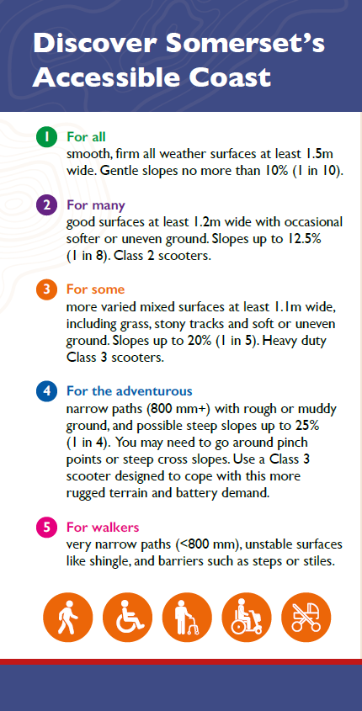
Somerset’s Accessible Coast Accessibility Scale

Sample screenshots
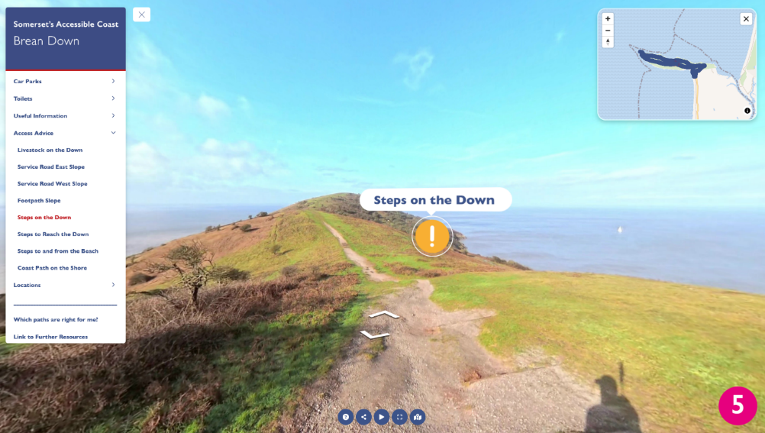
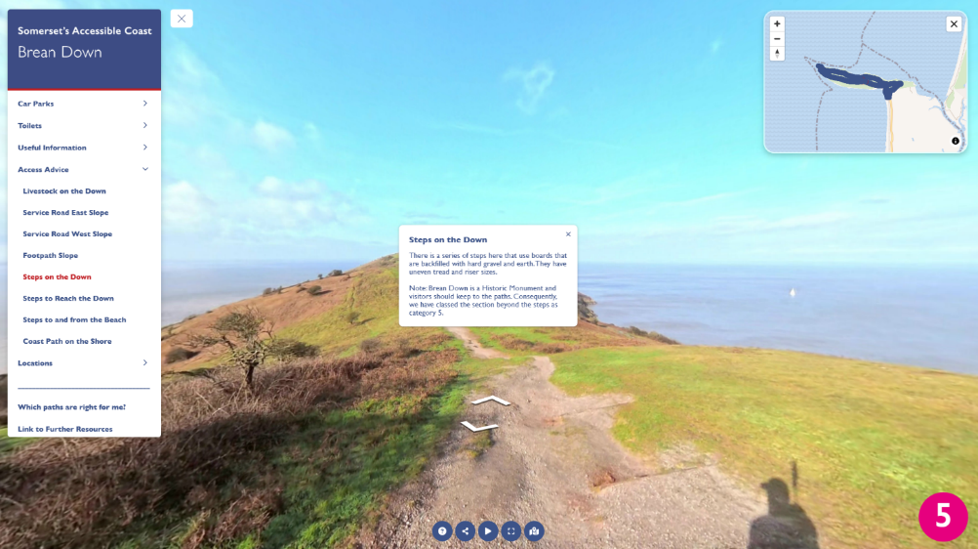
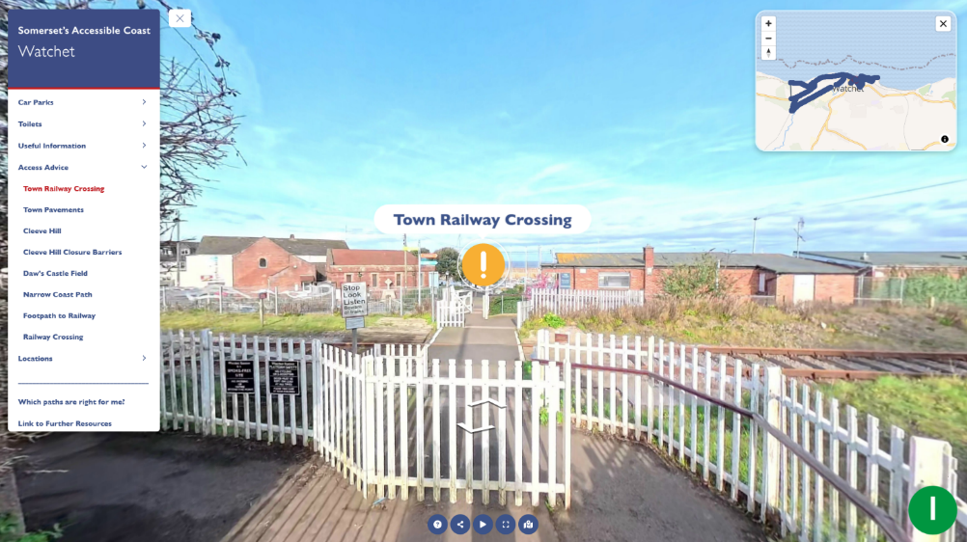
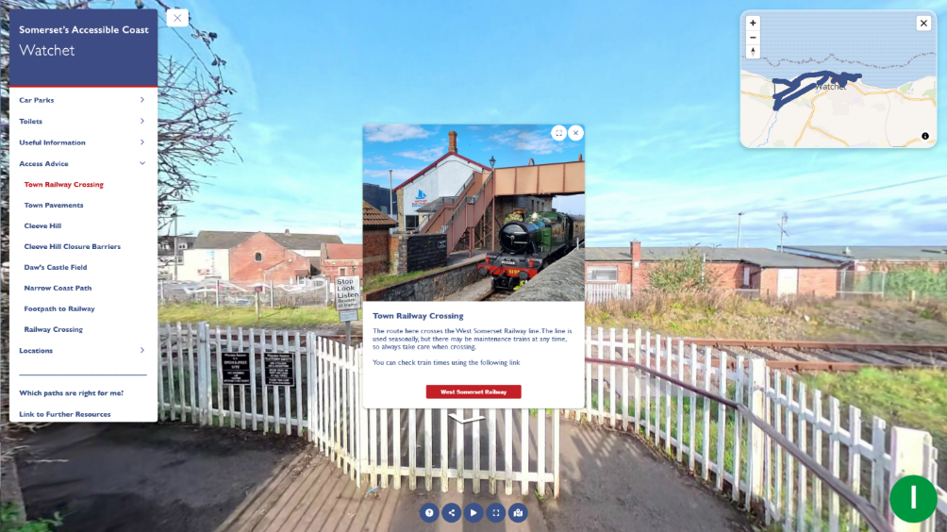

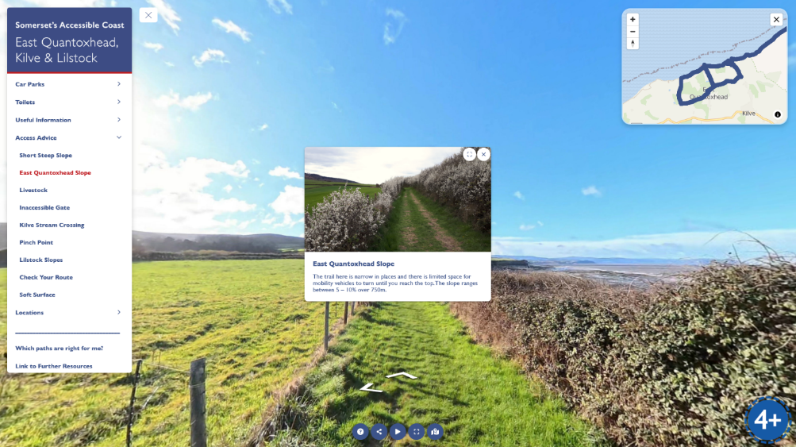
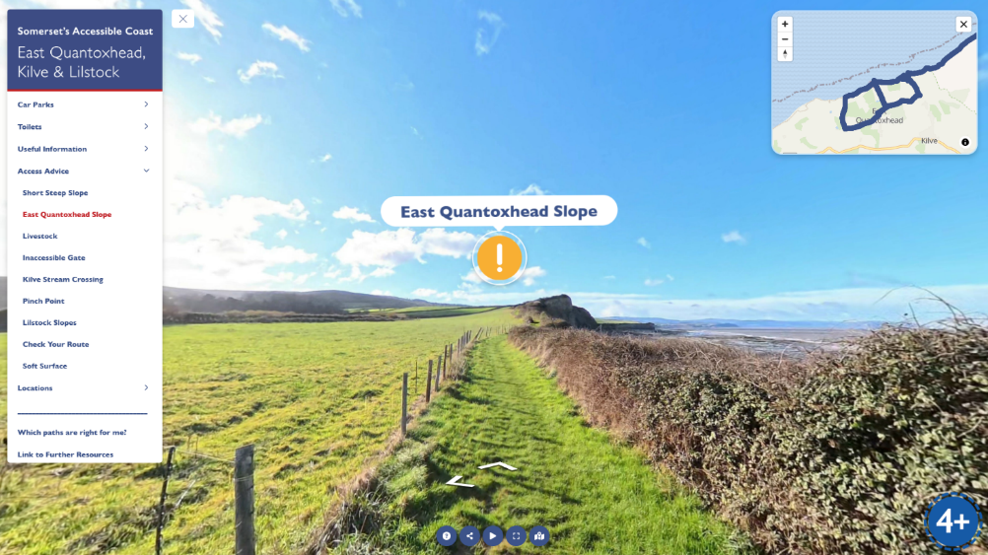

Location photos:
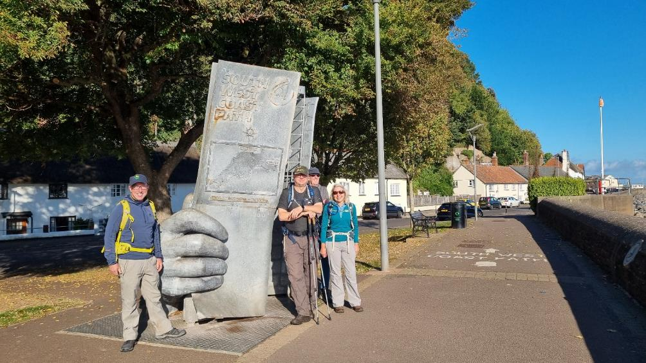
The SWCP Sculpture in Minehead
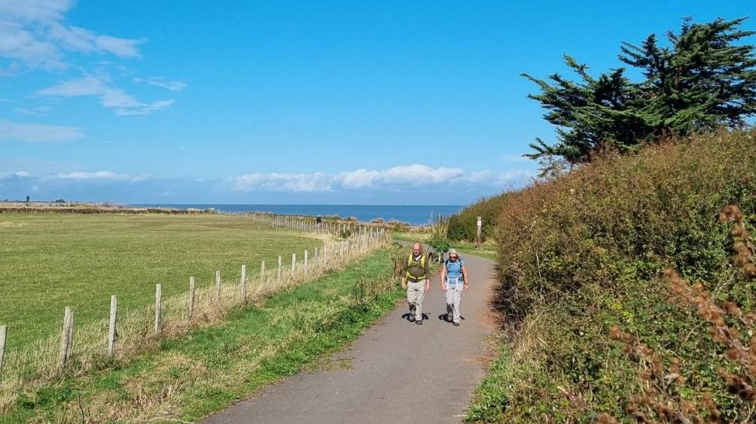
The Steam Coast Trail in Dunster
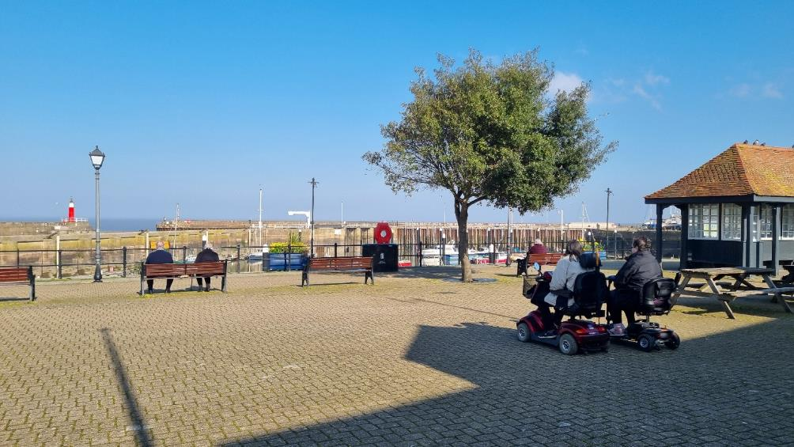
Taking in the view on Watchet Esplanade
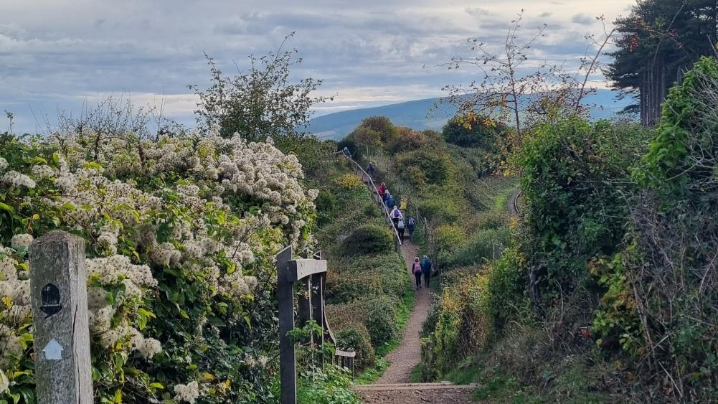 The Coast Path in Watchet
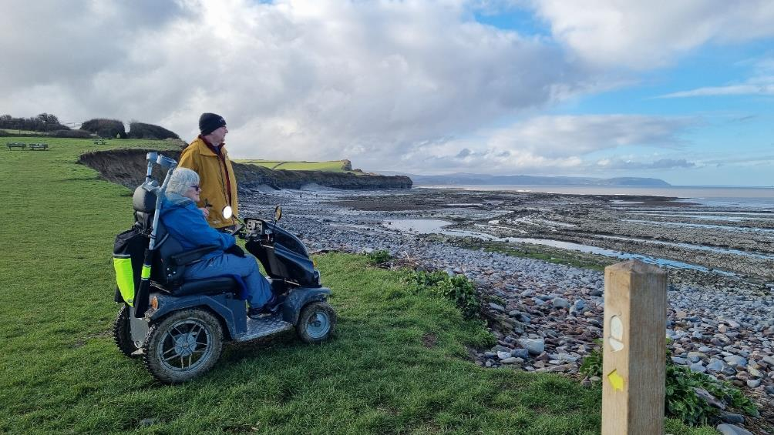
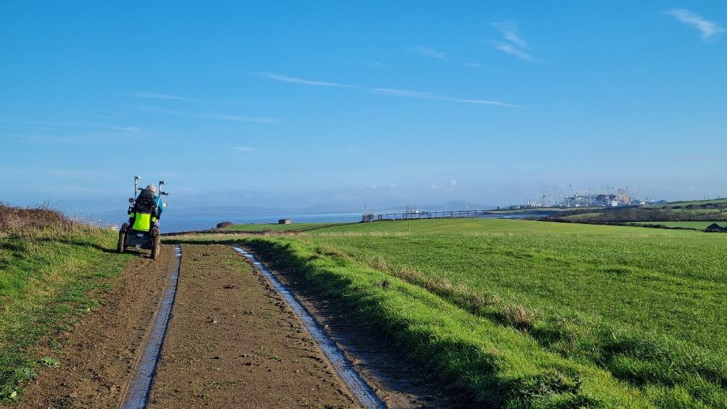Exploring with Diasbled Ramblers in Kilve
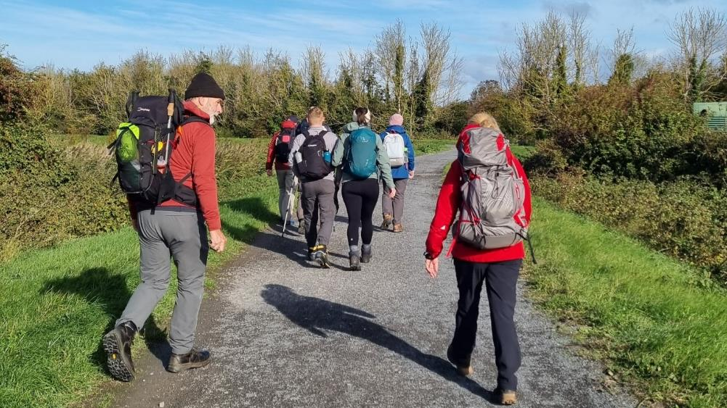
Hiking on the Coast Path at Apex Park, Highbridge
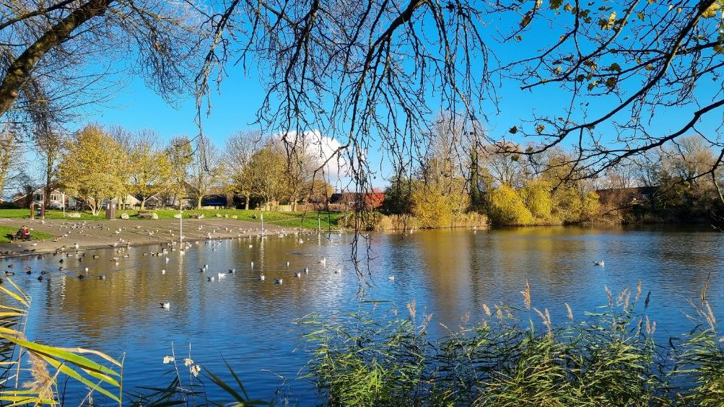
Apex Park Lake
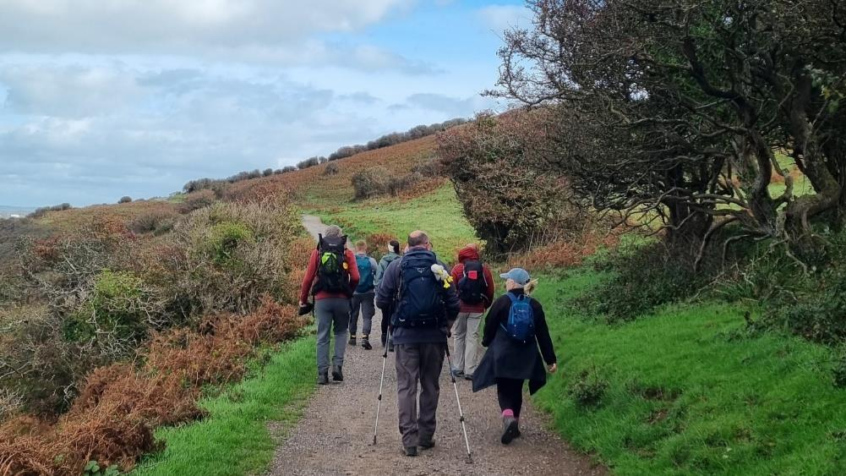
Hikers on Brean Down
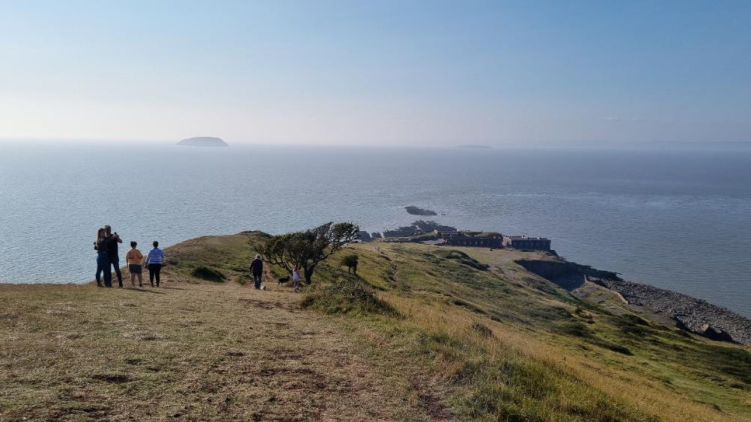
Brean Down with the Fort and Steep Holm Island ahead

